**MCQ - 19 (Third Normal Form)**

**Send Feedback**

Given a table subjects as shown below:

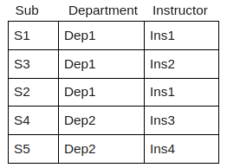

Identify the normal it violates. Also, give the ways to fix them.

Note: Write the normal form(s) comma separated and give the ways to fix them in bullet form from the next line.

**Solution Description**

Here, on observing we can say,

Sub--> Instructor (A subject is taught by instructor)

And Instructor--> Department (an instructor belongs to certain department)

So we can say Sub --> Department (using transitive rule.)

Hence, transitive dependency from the primary key.

Hence Violating 3NF.

Let's fix this by splitting the above table into two as below:

Table Ins_dep:

Instructor | Department

-------------------------

Ins1 | Dep1

Ins2 | Dep1

Ins3 | Dep2

Ins4 | Dep3

Table Sub_Ins:

Sub | Instructor

-------------------------

S1 | Ins1

S2 | Ins1

S3 | Ins2

S4 | Ins3

S5 | Ins4